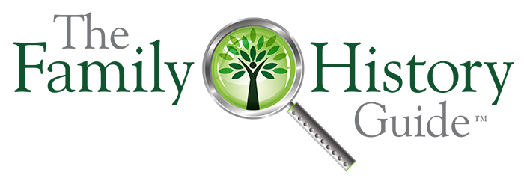
The Demo Training Guide

You have the opportunity to acquaint many others with one of the most useful and important family history tools available today—The Family History Guide. Please review this handout and explore TFHG to prepare for a great experience. We encourage you to let your love of family history and TFHG show!

PRE / POST-DEMO

- Smile, make eye contact, and say hello.
- Ask them a question: Have you heard about The Family History Guide? Are there any questions I can help you with? etc.
- Avoid “chasing” contacts or pressing the issue if they do not show interest.
- If they are familiar with The Family History Guide ask if they have seen the new menus.
- Invite the person(s) to watch a two-minute demo of The Family History Guide.
- After the demo, thank the guest and give a pass-along card if available.
- Close extra tabs and return to the Home page.

GET STARTED

Determine Individual Needs

- What kinds of things have you been doing with Family History?
- What kind of help are you looking for?
- Have you used TFHG before?
- Assess whether the person might be a Beginner, Intermediate, or Advanced.

What TFHG Is …

- A free, best-in-class website for learning family history and accelerating progress.
- Run by TFHG Association, a non-profit organization.
- Approved by FamilySearch as a training resource

Note: The following items are recommended, but you may adapt them to your local needs.

BEGINNER

- Show the Home page and Mission Statement.
- Explain the “Easier” section at the bottom.
- Click Get Started and walk through the page.
- Click and briefly show FS Project 1: Family Tree, opening a doc or video link. Show several Goals in the header area.
- Show the top menus and open another Project, or Activities, or a Country page.
- Show how clicking the logo returns to the Home page.
- Optional: In the Home page, also show Help for Beginners, Finding What You Need, and The Learning System. If needed, show Computer Basics in the Intro menu.
- Optional: Show the Blog & YouTube Channel.

INTERMEDIATE

- Show the Home page, Mission Statement, and top menus.
- Open and explain FS Project 1. Show Choices and Steps, and click an article or video link. Also show Exercises.
- Show some additional Goals in the header area.
- Open Project 2: Memories and select a couple of Goals to show there.
- Open Ancestry Project 2, Goal 1 & explain.
- Optional: Show Project 2, Goal 1 for MyHeritage and Findmypast.
- Open Family Activities and show what is there.
- Open the Countries page and open a country of interest. Find a lightning bolt in the header show how to use it in a QUIKLinks section.
- Show the Vault. Scroll, then use a header link.
- Optional: Show the Online Tracker (use your account); or, show the Word Tracker page.
- Show the Blog and YouTube Channel.

ADVANCED

- Show the Home page, Mission Statement, and top menus.
- Open and briefly show FS Project 4: Discover and its Goals in the header. Emphasize the later Goals for researchers.
- Briefly show the Partner menus. Items of interest may be Research and DNA for Ancestry or MyHeritage.
- Open the Knowledgebase; show a few topics.
- Open the Countries KB; show a few topics.
- Open a Country page and show the QUIKLinks.
- Optional: Show the Online Tracker (use your account); or, show the Word Tracker page.

CONSULTANTS / FAITHS

- Use the Beginner, Intermediate, or Advanced points shown above.
- For Consultants, show the Course Catalog.
- For Consultants, briefly explain or show the Certified Trainers page.
- Optional: Show the Catholic, Protestant, or Church of Jesus Christ pages.
- For Latter-day Saints, show the Come, Follow Me Companion page and the Leadership page.
The last Goal in each Activities category is for Latter-day Saints.

QUESTIONS

- Where do I find …? To answer questions about where to find items in TFHG, you can use the Topics page, Features Help, or Search.
- How is TFHG funded? The Family History Guide Association receives financial support from donations, large and small. We also have a new Marketplace site, where people can buy gifts to support us. You can see a list of major donors in the footer of each page on the website.
- You can find answers to other questions in the FAQs link in the Intro menu.

TIPS

- Negative responses—Although rare, do your best to clear up misconceptions but avoid arguing or debating. Point out the benefits of The Family History Guide whenever possible.
- Sidetracks—It’s OK to show other sites in a demo, but avoid spending long stretches on any site besides The Family History Guide (even FamilySearch, Ancestry, etc.) The main objective is to show TFHG.
- Long stories—If a guest launches into a story about their family history, smile and be polite, but look for opportunities to get back to The Family History Guide. Be aware of anyone else standing near the demo station: it’s OK to explain to the person that you need to help someone else.
- Lack of interest—If the guest appears bored or impatient, ask a question or shorten the demo.
- See opportunities—Don’t let chatting or other activities cause you to miss opportunities for demos.
- If you have a notable experience with a guest or hear a memorable quote, please jot it down and share it with us via email: info@thefhguide.com

